GRAPHIC

A gallery series & multimedia installation

Samples Only
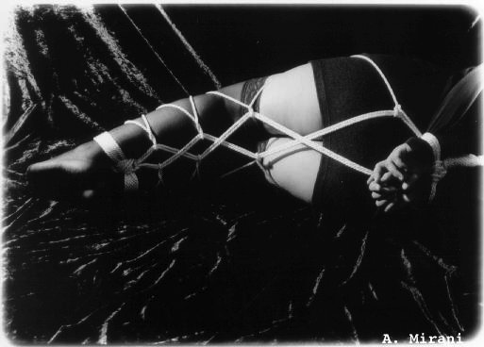

Scenario
A woman finds herself tied to a chair – there are two deviating timelines, from two possible scenarios - one in which she struggles to escape, and another in which she gladly stays.

Intention
To acknowledge the multiplicity of sexuality – how violence and sex intertwine through carnality, and how enjoyment is dependent upon context.

Preferred Model
Allegra Keogh
http://www.modelmayhem.com/742834

Other Possible Models
Angela Mildred Russell
http://www.modelmayhem.com/2741934
S Elizabeth M
http://www.modelmayhem.com/2626237
Lydia Kotahitanga
http://www.modelmayhem.com/2993000
Amy Peachy
http://www.modelmayhem.com/3092968

